MVP Concept for React Web App: Nick's Tac Toe Madness

# Wireframe:

I have created a wireframe for my Tic Tac Toe React web app. The main view will display a 3x3 grid representing the game board. Each cell in the grid will be a button, and when a player clicks a button, their move (X or O) will be displayed in the cell. At the top of the screen, there will be a message area to show the game status, such as who won or if it's a draw. Additionally, there will be a "Restart" button to allow players to start a new game.

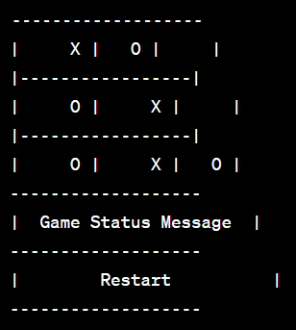

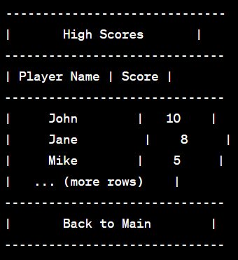

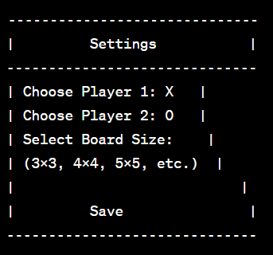

# MVP Features:

1. Display the Game Board:

- The app will display a 3x3 grid representing the Tic Tac Toe game board on the main page.

- Each cell in the grid will be a button that allows players to make their moves by clicking on the cells.

2. Game Logic:

- Implement the game logic to check for a win or a draw after each move.

- The app will determine if there is a winning combination of X or O symbols on the board and display a message accordingly.

- If the game ends in a draw, it will also show a message indicating the draw.

3. Restart the Game:

- Add a "Restart" button to the main page that allows players to reset the game board and start a new game.

- Clicking the "Restart" button will clear the board and reset the game state.

4. High Scores Page:

- Create a separate page for displaying high scores.

- The high scores data will be fetched from the server and displayed in a table format.

- Include a "Back to Main" button on the high scores page to allow users to navigate back to the main game page.

5. Settings Page:

- Implement a "Settings" page where players can customize the game settings before starting a new game.

- Players can choose their preferred symbol (X or O) for Player 1 and Player 2.

- Additionally, they can select the desired board size (e.g., 3x3, 4x4, 5x5, etc.) for the game grid.

- The "Save" button allows players to save their chosen settings and return to the main game page.

# Server and Data:

1. GET and POST Endpoints:

- Set up a server using Express.js to handle GET and POST requests.

- Create a GET endpoint to fetch high scores data from the server.

- Implement a POST endpoint to save new high scores to the server.

2. High Scores Data:

- The server will store high scores data in a database using Sequelize.

- Each high score entry will include the player's name and their score.

- When a game ends, the player's score will be calculated based on their performance (winning or losing).

# Presentation:

For the presentation, I will demonstrate the main functionality of the Tic Tac Toe game app, including the interactive game board, game logic, and the ability to restart the game. Additionally, I'll showcase the high scores page and explain how players' scores are saved and retrieved from the server. The presentation will aim to give an overview of the app's features, its implementation, and its potential for further enhancements.